Students Handout

Introduction to Web API Workshop 1

Welcome to the Web API Workshop! In this hands-on session, we will explore the implementation of a simple Web API using the Repository Pattern and two controllers: UserController and JobController. The workshop covers essential concepts such as registration, login, fetching job listings, and posting new jobs.

Technologies Used

C#

ASP.NET Core

Entity Framework

AutoMapper

Project Structure

The project is organized into two controllers, each responsible for specific functionalities:

UserController:

Handles user-related operations such as registration and login.

Implements a repository pattern for user data.

Utilizes AutoMapper for mapping between DTOs and models.

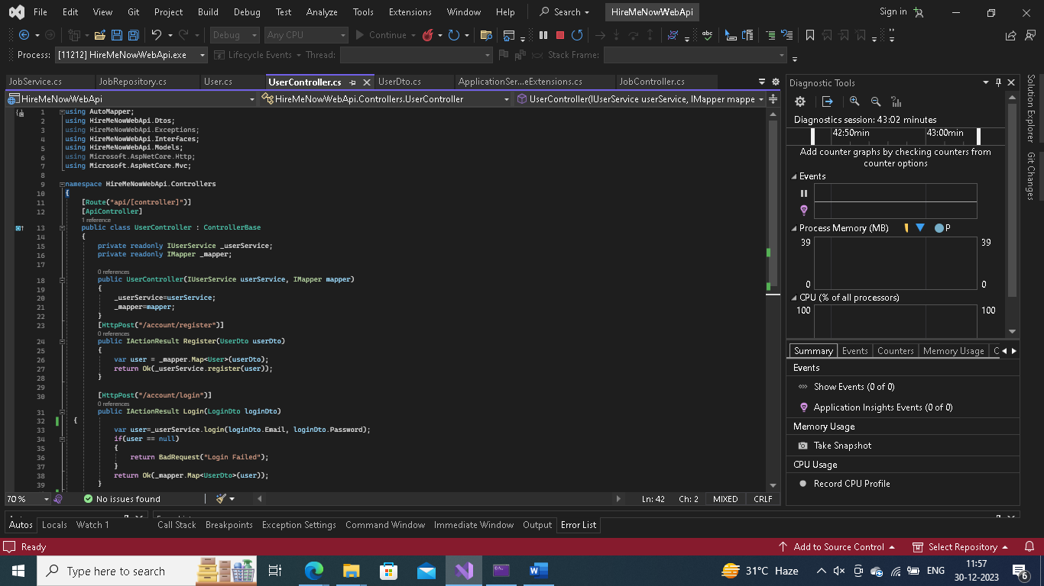

JobController:

Manages job-related operations such as retrieving job listings and posting new jobs.

Follows the repository pattern for job data.

Uses AutoMapper for DTO to model mapping.

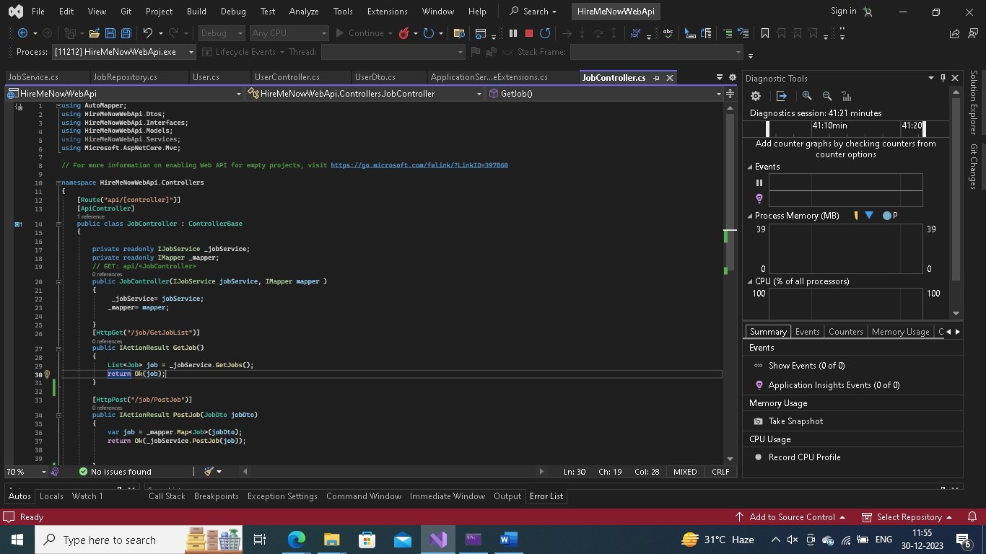

Getting Started

Clone the repository or create a new ASP.NET Core project.

Install necessary packages like AutoMapper.

Set up database connections and migrations if using a database.

Implement the logic inside the controllers according to the provided code snippets.

Workshop Tasks

* User Registration:
* Understand the registration process in the UserController.
* Implement the registration logic in the Register method.
* User Login:
* Explore the login process in the UserController.
* Implement the login logic in the Login method.

Fetch Job Listings:

Study the JobController's GetJob method.

Implement the logic to retrieve job listings.

Post a New Job:

Analyze the JobController's PostJob method.

Implement the logic to post a new job.

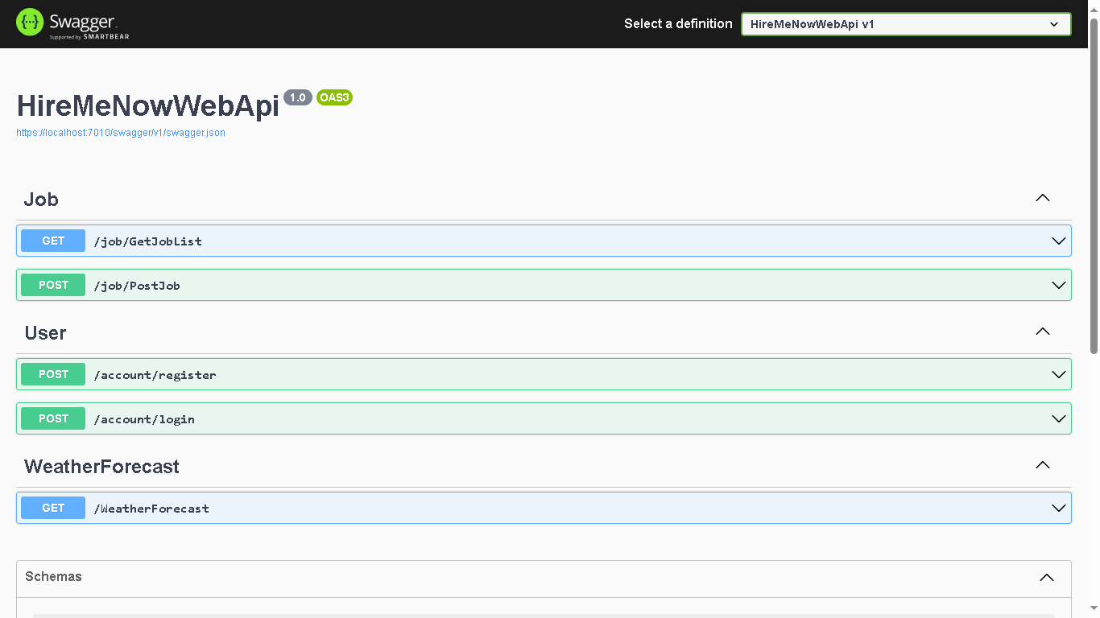

Conclusion

Congratulations on completing the Web API Workshop! You've learned about the Repository Pattern, controllers, and essential API operations. Feel free to explore and extend the project with additional features.

Happy coding!